Logbook Week 3
January 27, 2026

On the third week we presented our project proposal to the class. We also made some progress on finalizing some more station designs, starting the search for parts and their part numbers and CAD files to import, taking measurements of the table we are mounting things on, and making clearer objectives.

Here’s an image of the table:
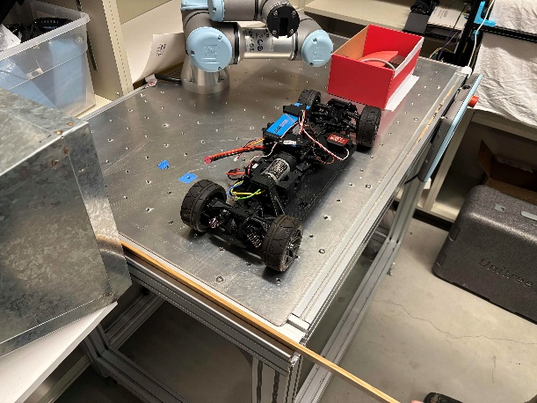

We finalized a design for the base conveyor system that brings the sushi roll along to each station. We are actually going to make it a linear slide with a motor that moves the platform. The principle for moving the platform can either be the threaded bar shown in the image below or a belt and drive system or something else.
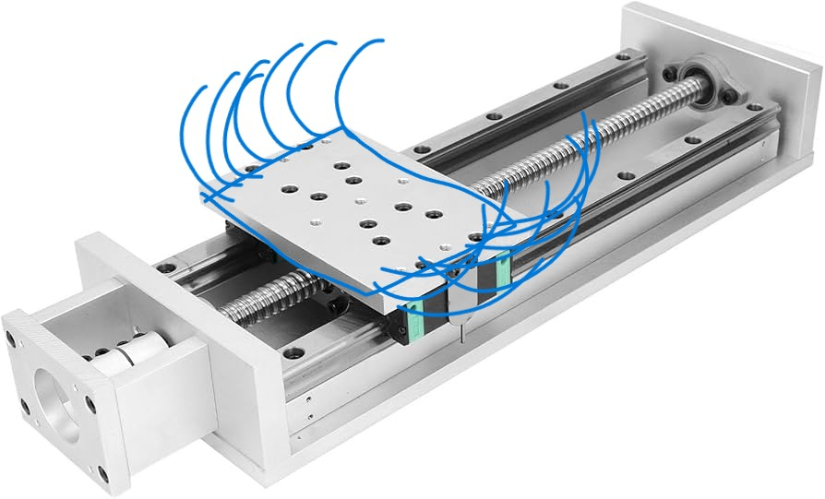
A problem we thought of was how we were going to place the laid-out sushi ingredients onto the ribcage roller, or how the ribcage roller would wrap around the conveyor belt to roll the sushi. That is why we decided that the sushi will be laid on the ribcage roller from the very start, then ingredients will be laid as the platform moves, then when it’s done the ribcage roller will roll it up and come back down, then the cutter will come down. This solves all our problems. We realized the drawback with this design would be that our machine is a batch process and not a continuous process but we are fine with that. The platform will move back to the start to get ready for the next batch.

We also finalized an idea for dispensing the fish. It is our default plan unless we can think of a better design. Here is the fat marker sketch:
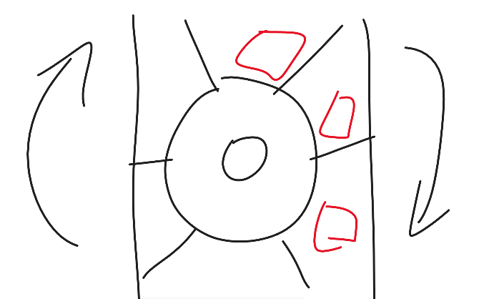
It is a wheel with flaps that ensure the pieces of fish are separated and the flow is continuous.

Things we will work on next week:
- Next week we plan to continue designing our stations and shopping for parts. We will start importing parts into our CAD and making our BOM. We have the principles of operation for each station already, now it’s time to start working on the design and purchasing
- I want to find out the size of the threaded holes on the table so we know what size screws to order for mounting our stations
- Jacob and I want to start doing math on the forces we need for our stations, translate them into torque, then shop for suitable motors
- Once we have the motors we also need to figure out the controller for them
- We have also started discussing doing work outside of the 3-hour class every week. I personally want to shop for parts or design on CAD on my spare time

